JAPAN

Creating table cid_japan

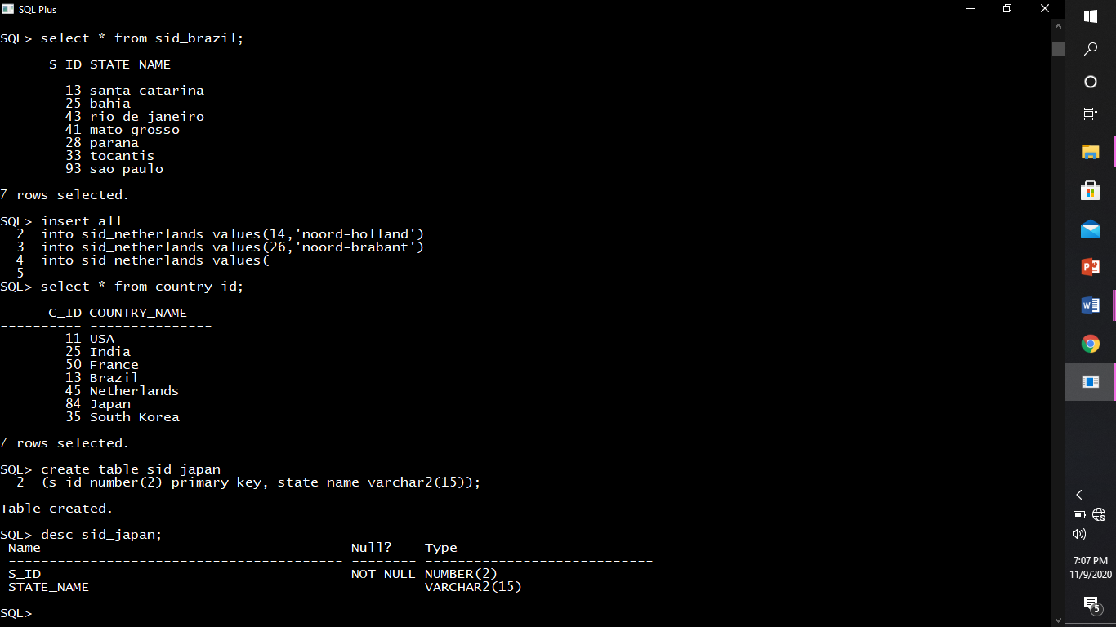

Describing structure of sid_japan.



Inserting rows into sid_japan

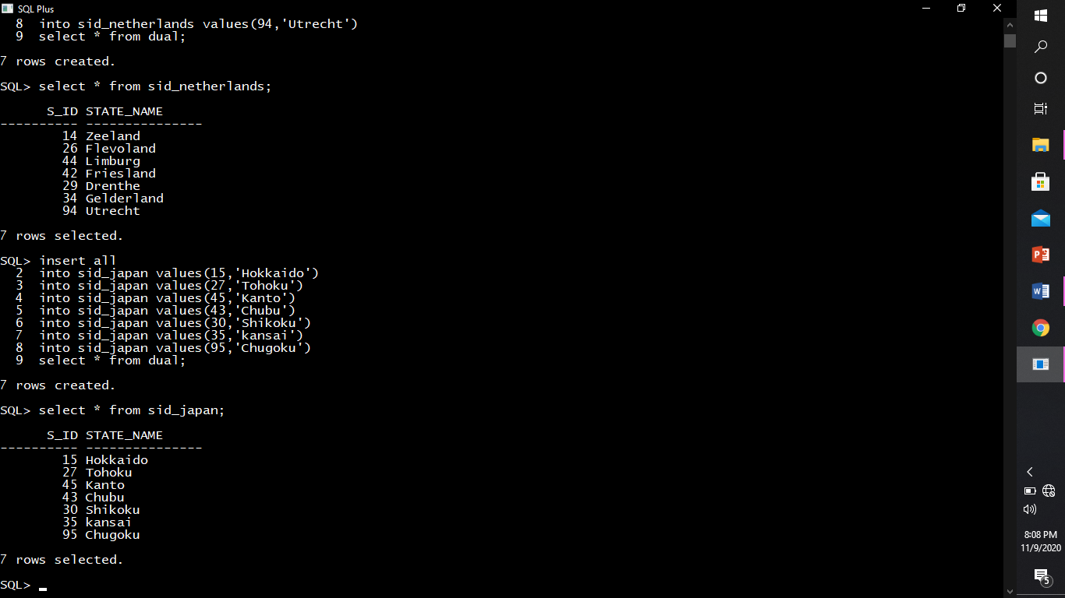

Creating table japan_states.

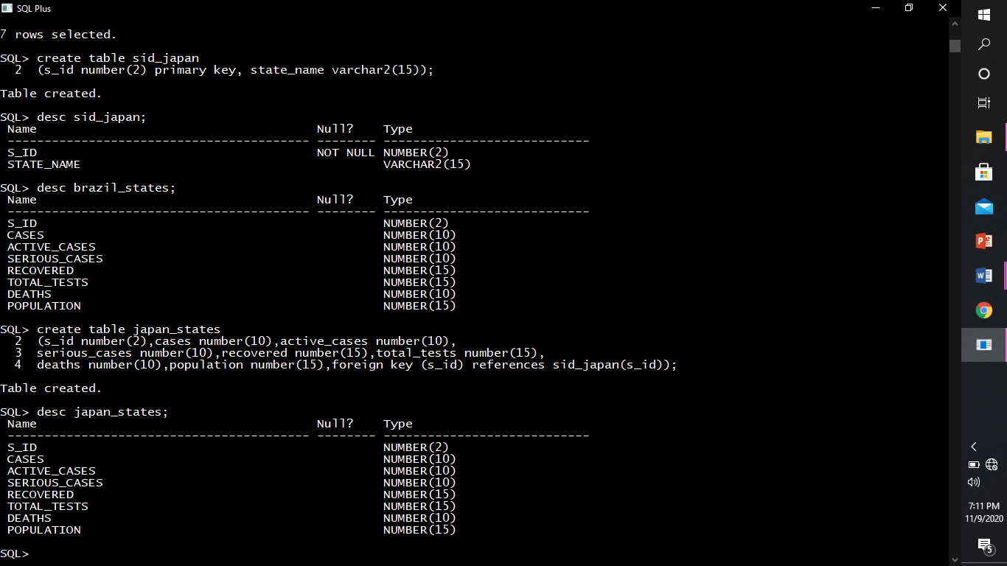

Describing structure of japan_states.



Inserting rows into japan_states.

